Happy Hanukkah! Merry Christmas! Happy New Year!

Hello Everyone! I wanted to wish you the most blessed and joyful Christmas & Hanukkah season! I also wish you a balanced, fruitful 2011. As we all know, a big part of the joy and blessings in life comes from charity and caring for others.

As many of you already know, each year, in lieu of a Christmas card, we make a donation to FriendshipWorks in your name:

This organization was formerly known as Match Up Interfaith Volunteers. What do they do you ask? Let me share from their website:

Our Friendly Visiting program matches volunteers with elderly or disabled adults who would like somebody to visit them on an ongoing basis.

Without the stimulation that social interaction and friendship provide, an isolated elder can experience poor health, a lack of strength and energy, depression, and other physical, emotional, and mental health problems. Weekly friendly visits can change all that. ☺



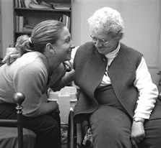
If you would like to personally help Friendshipworks, call 617-482-1510 or go to their website:

www.F4elders..org

Thank you all for your trust & confidence. I look forward to serving you all in 2011
Chris Grande

